Combine NCA_ ARC1 Train =51 solved tasks

025d127b
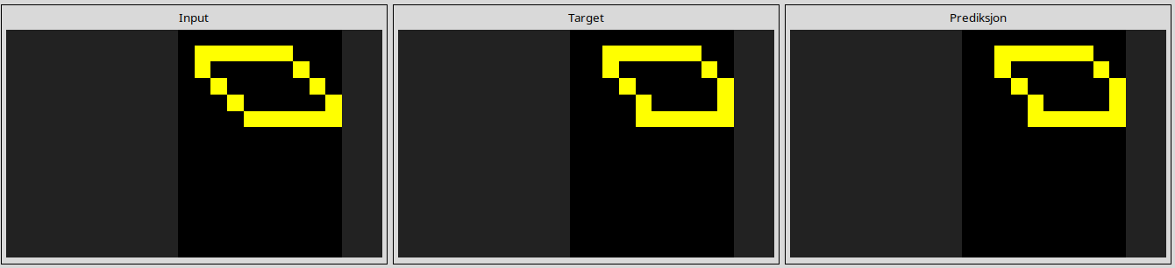
0962bcdd
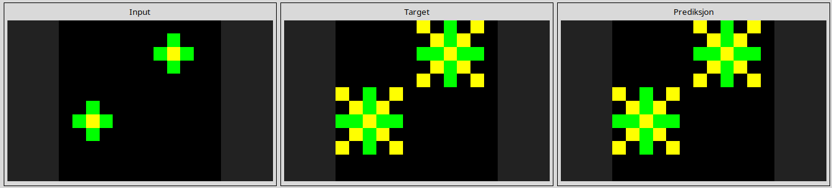
1190e5a7
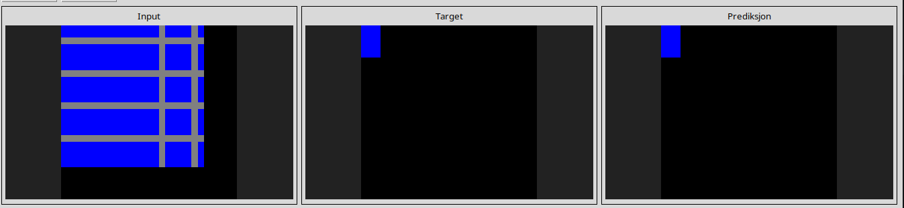
1fad071e
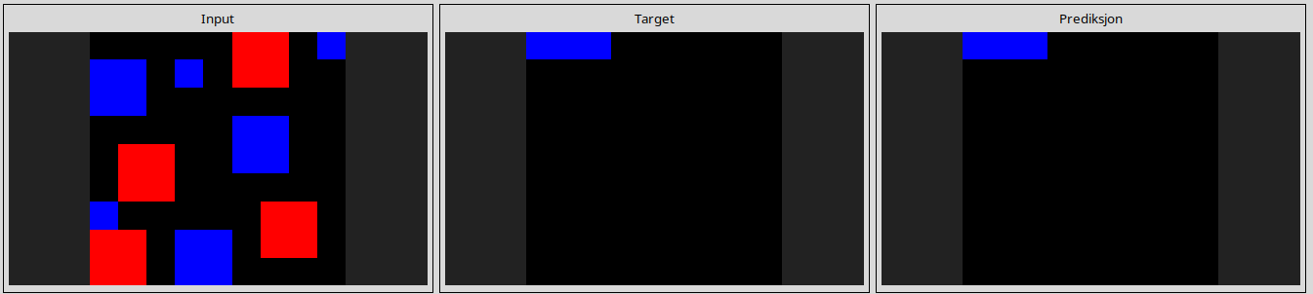
23581191
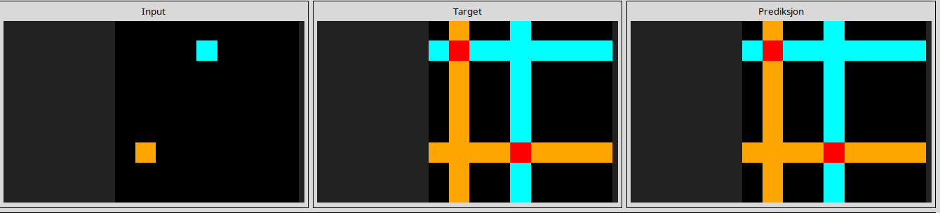
25d8a9c8
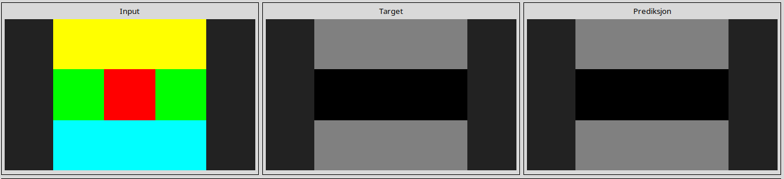
25ff71a9
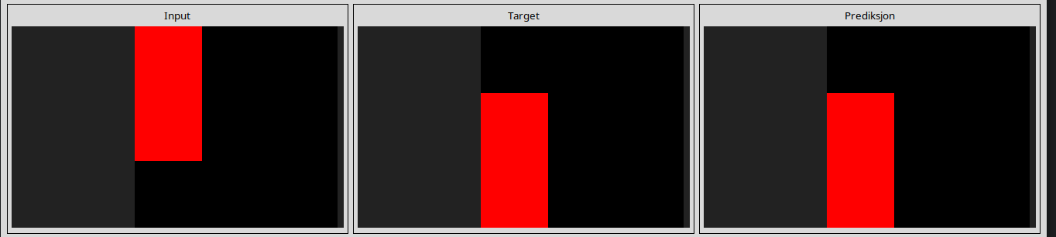
2dee498d
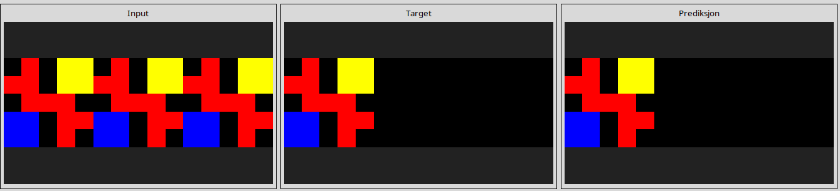
3618c87e
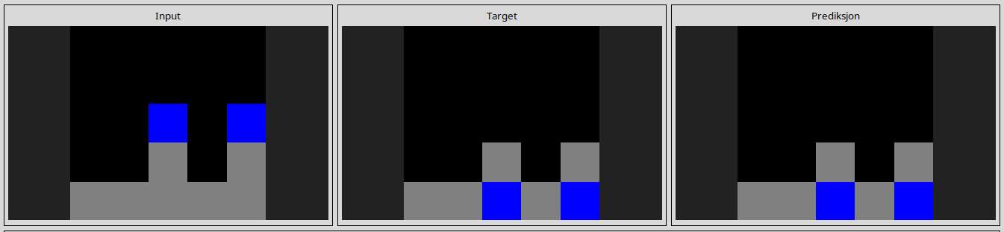
3aa6fb7a
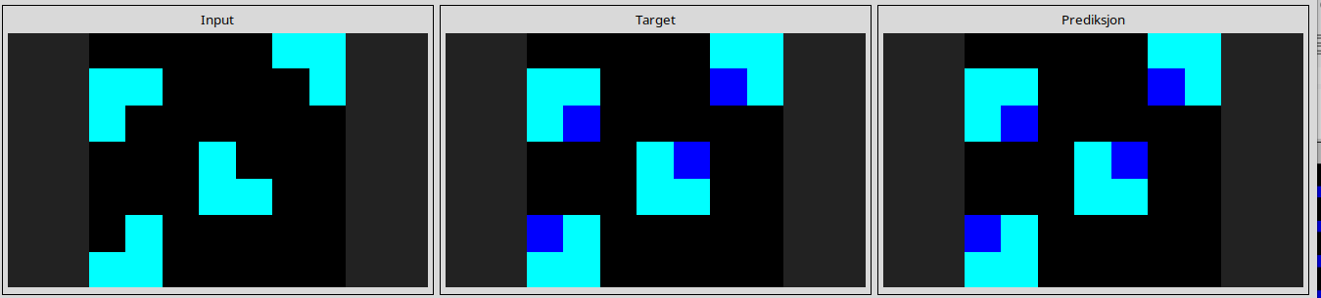
3ac3eb23
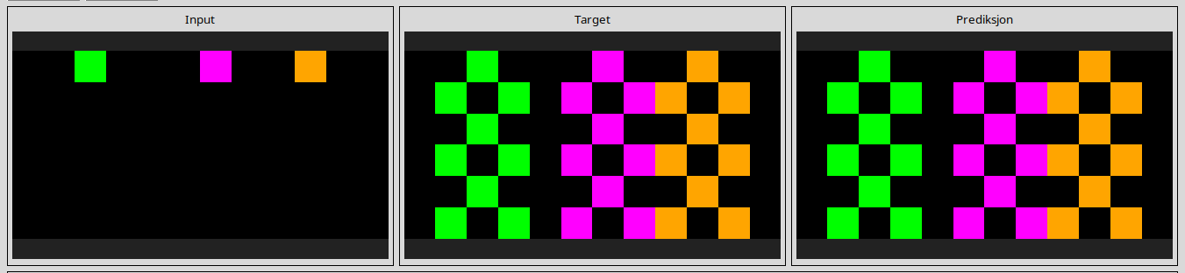
3befdf3e
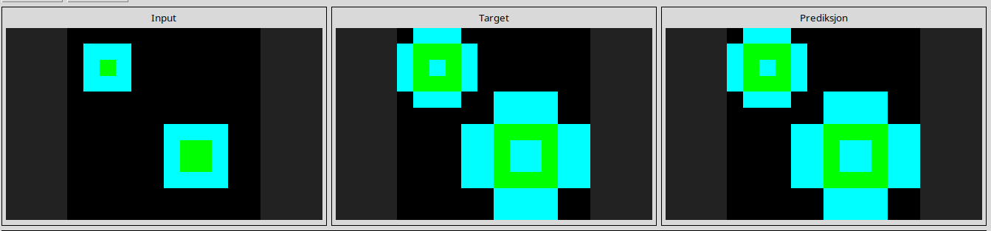
3c9b0459
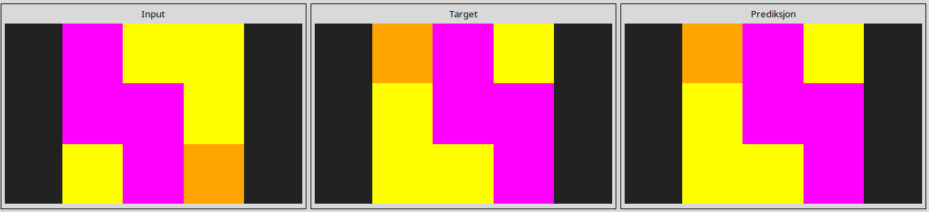
42a50994
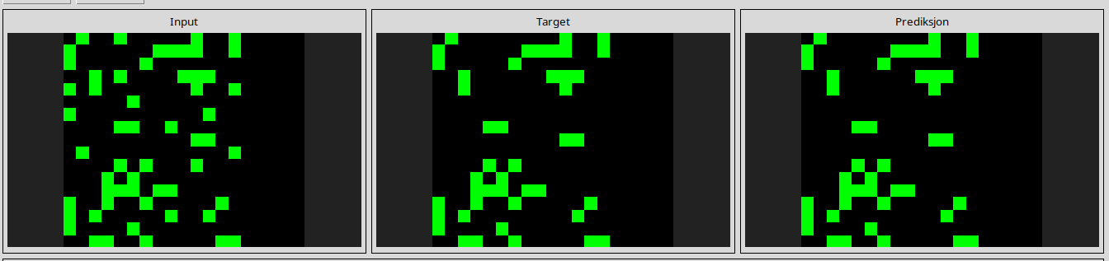
4347f46a
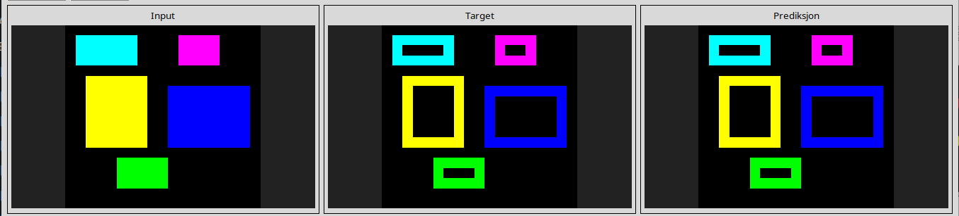
44f52bb0
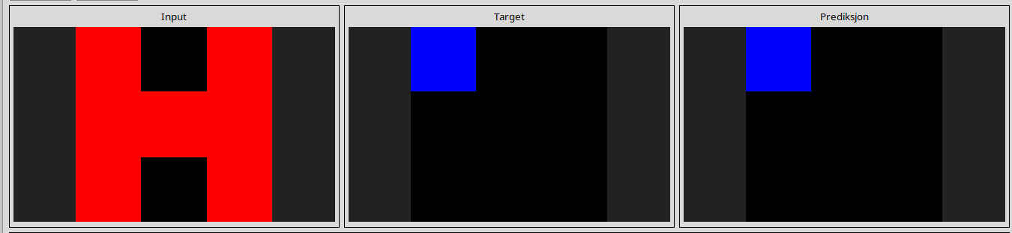
49d1d64f
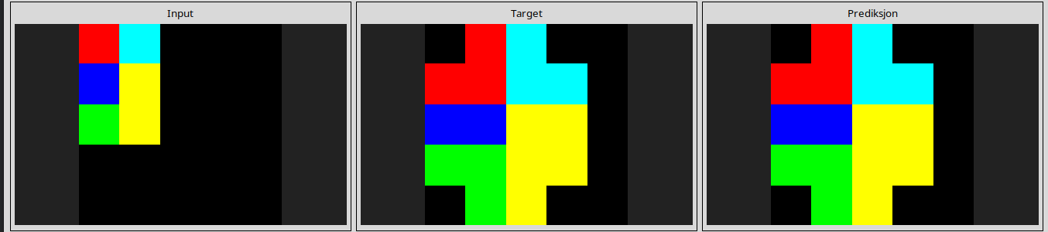
60b61512
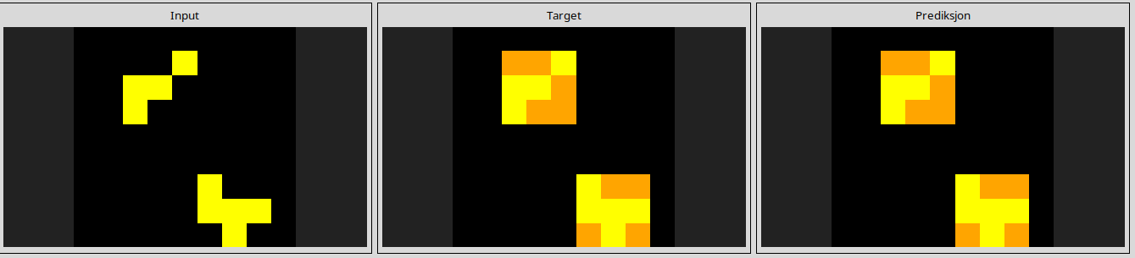
623ea044
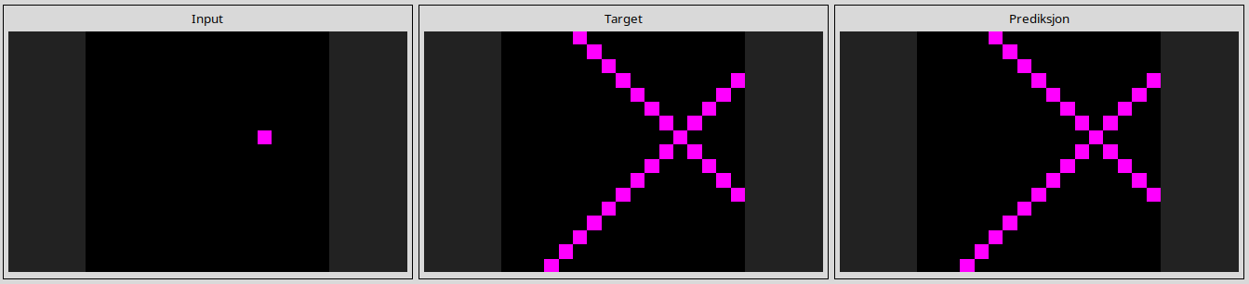
67385a82
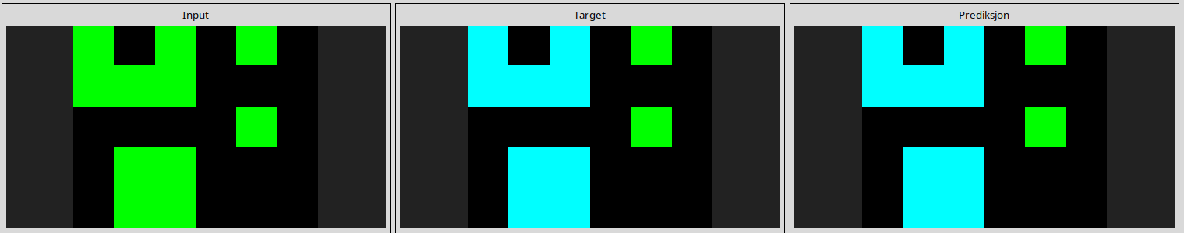
694f12f3
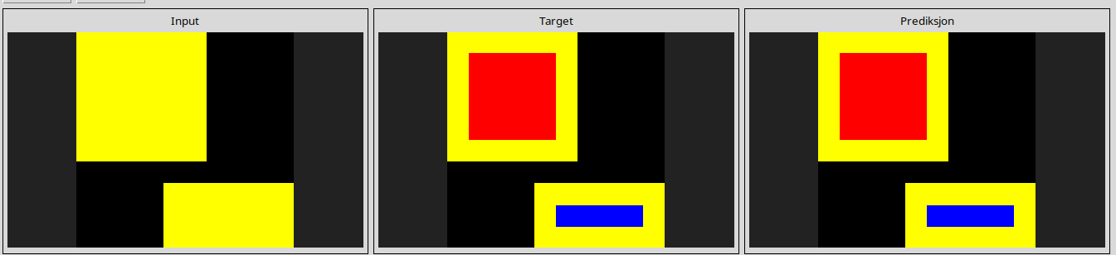
6c434453
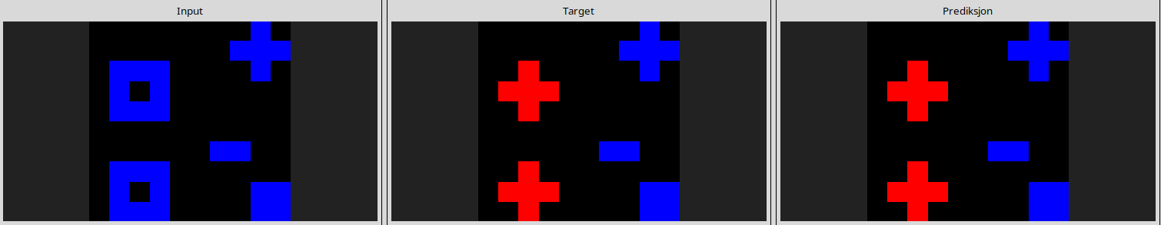
74dd1130
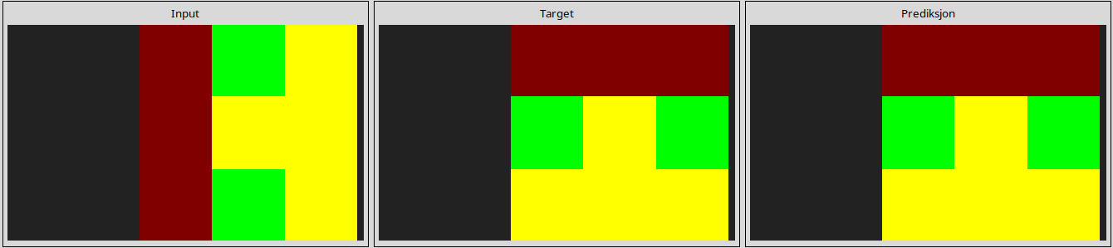
794b24be
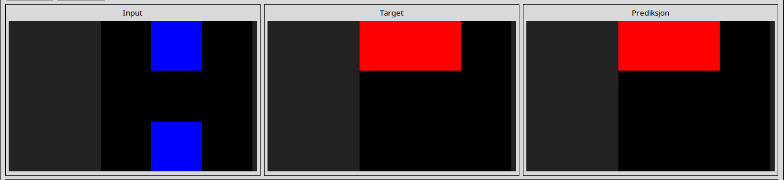
7b7f7511
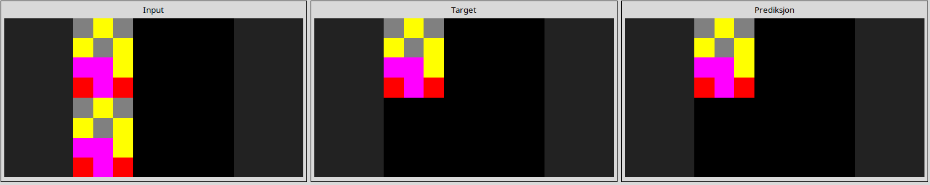
7ddcd7ec
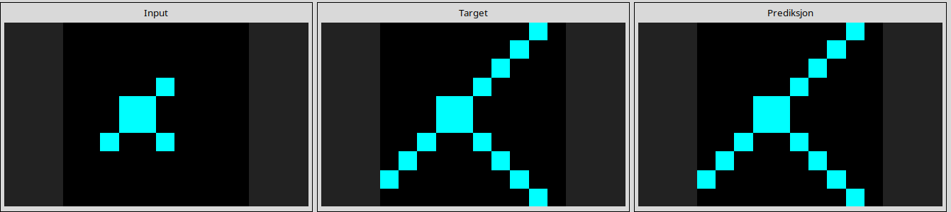
7f4411dc
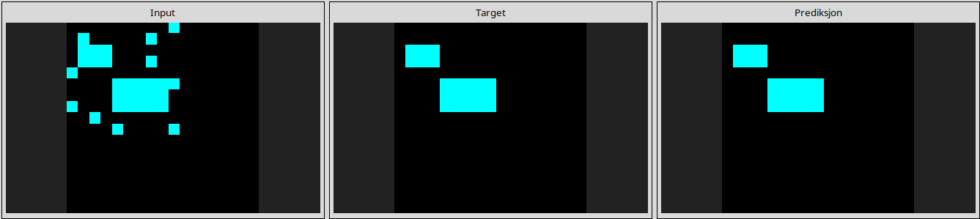
810b9b61
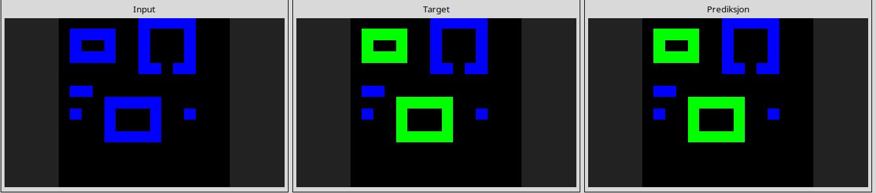
93b581b8
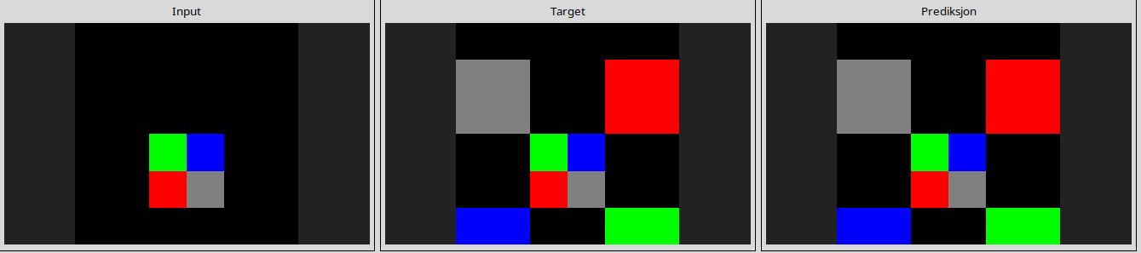
a5313dff
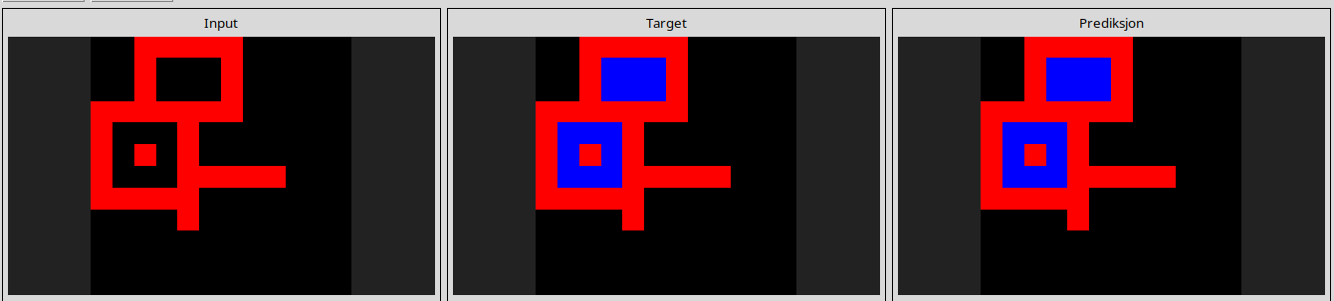
a65b410d
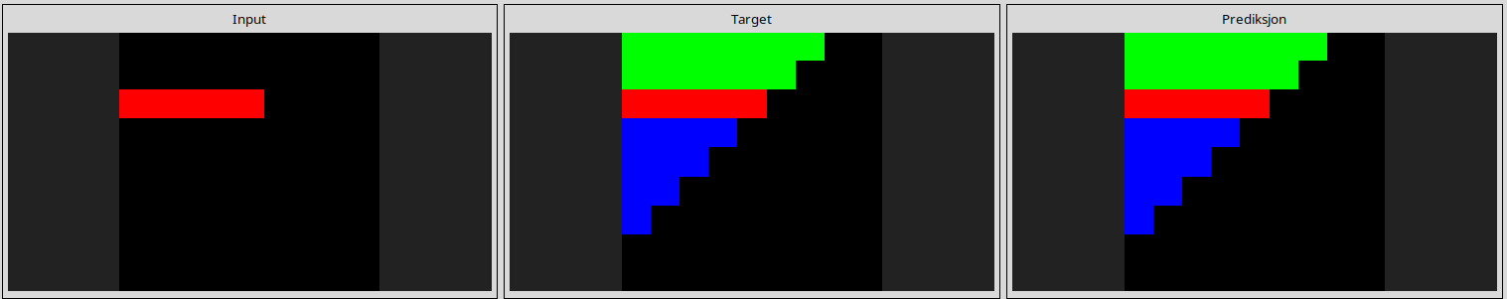
a8d7556c
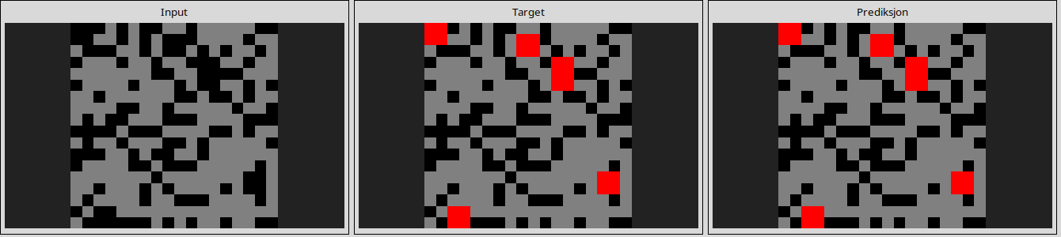
aedd82e4
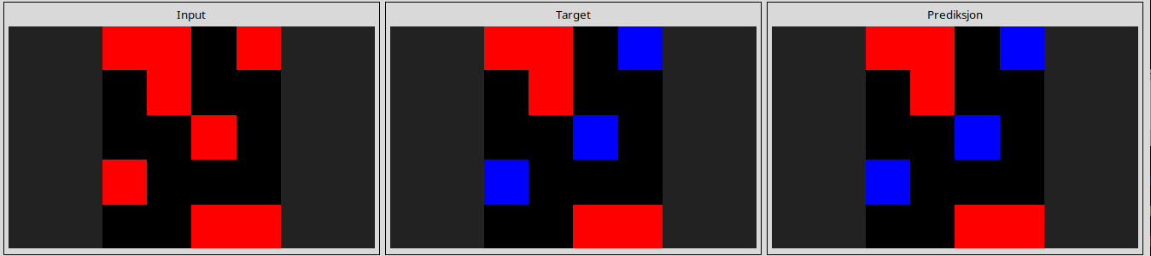
b6afb2da
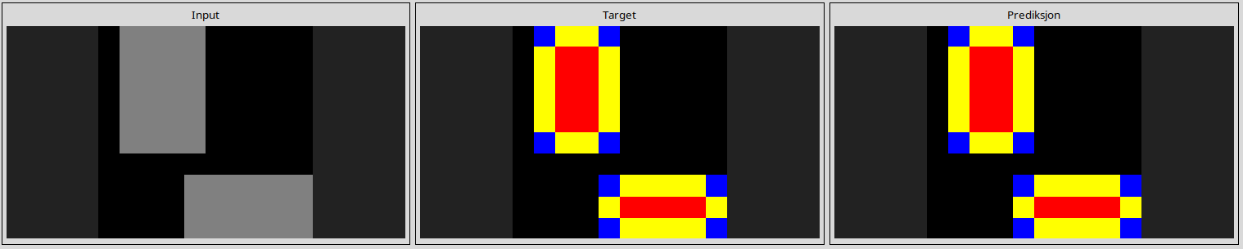
ba97ae07
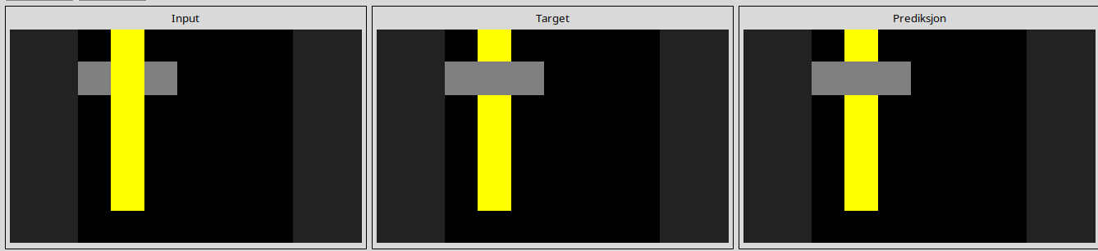
bb43febb
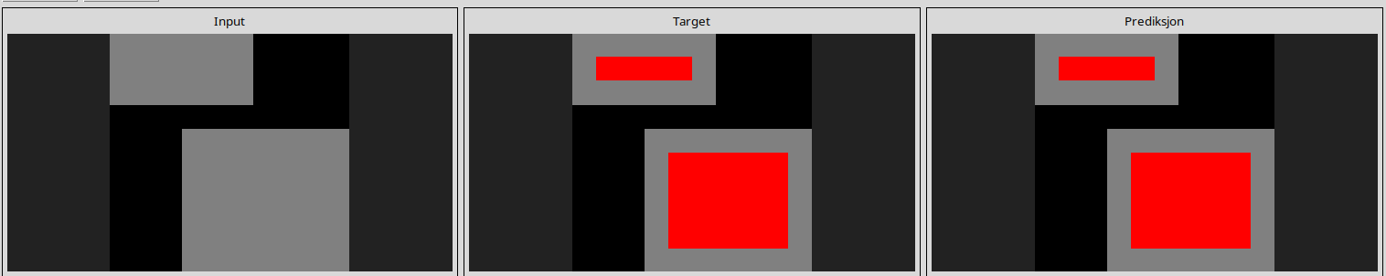
bbc9ae5d
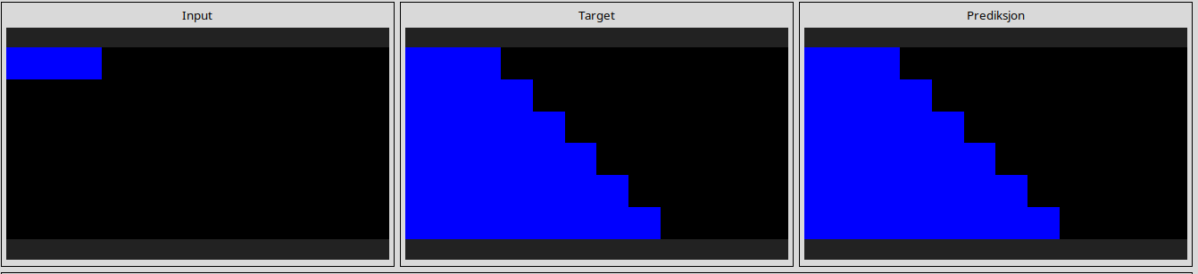
bda2d7a6
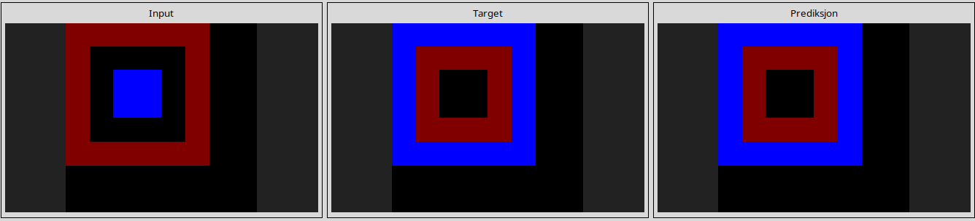
c0f76784
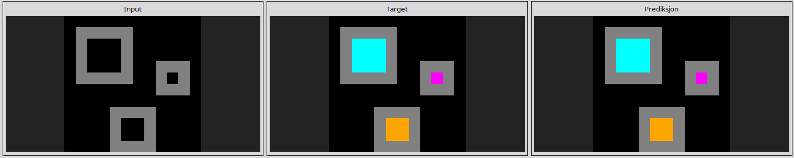
ce22a75a
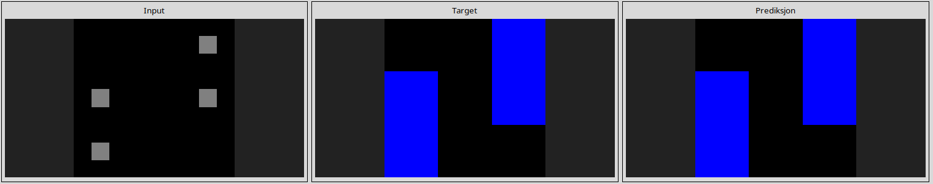
d037b0a7
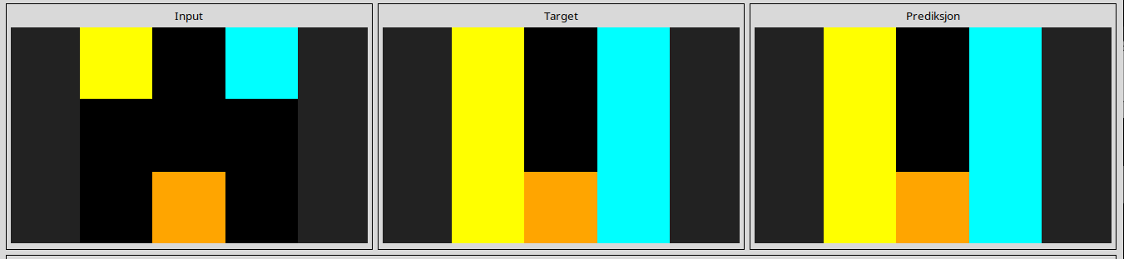
d06dbe63
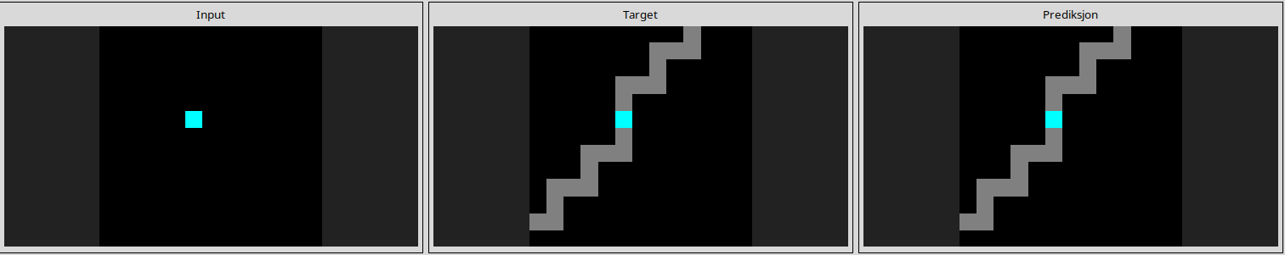
d10ecb37
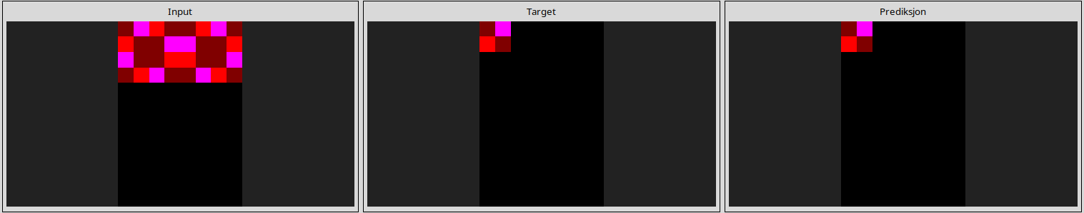
d364b489
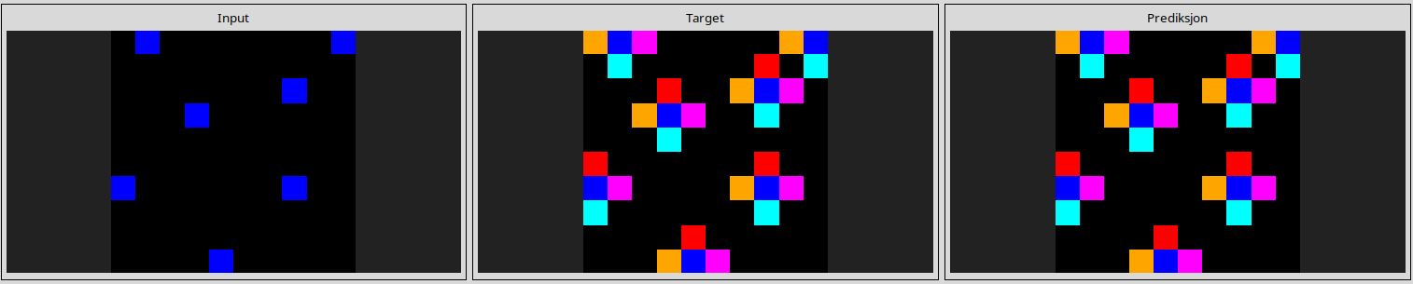
d4f3cd78
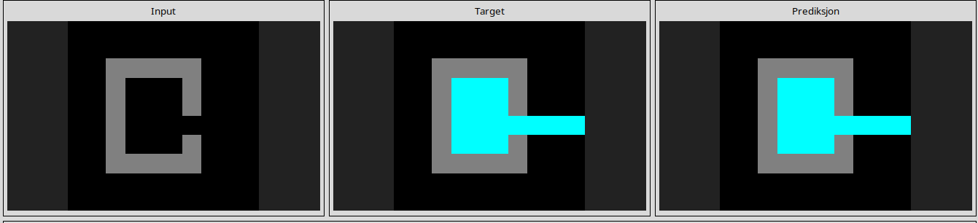
d631b094
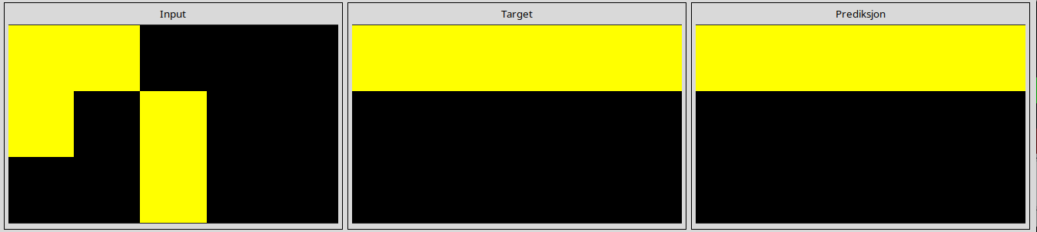
ded97339
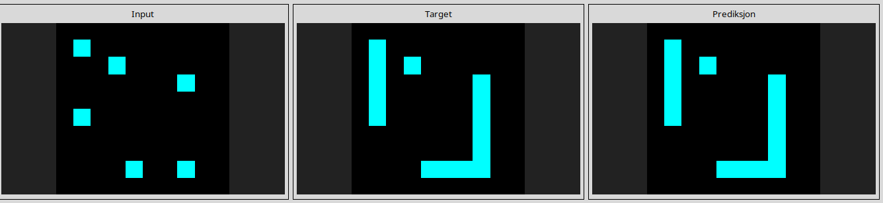
e8593010
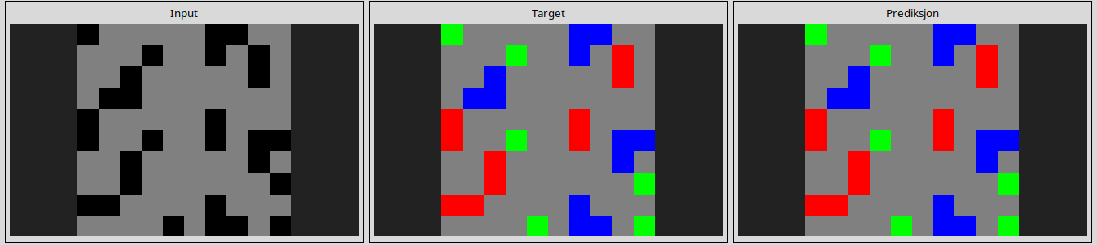
e9afcf9a
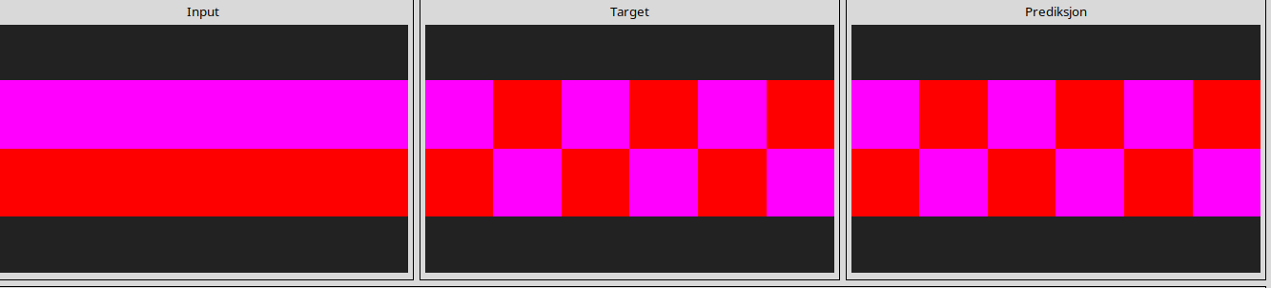
ea786f4a
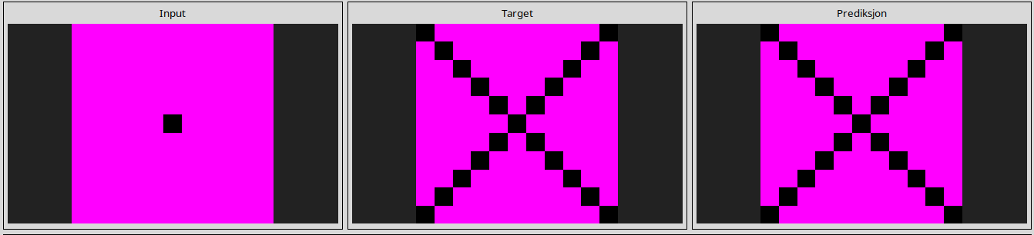
ecdecbb3
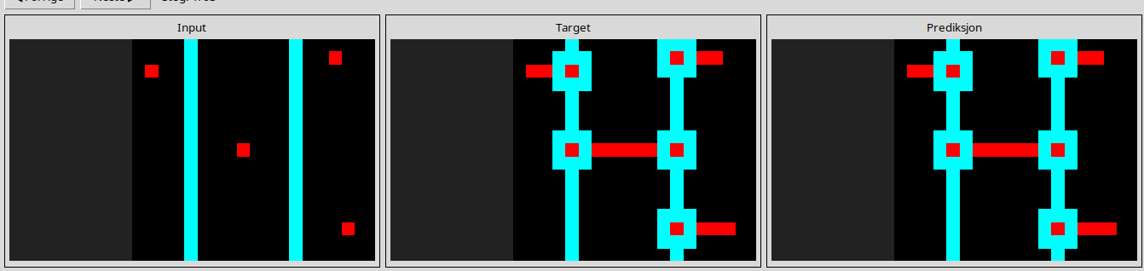
----------------------------------------------------------------------------------------------------------.-------------
Almost solved tasks

7e0986d6
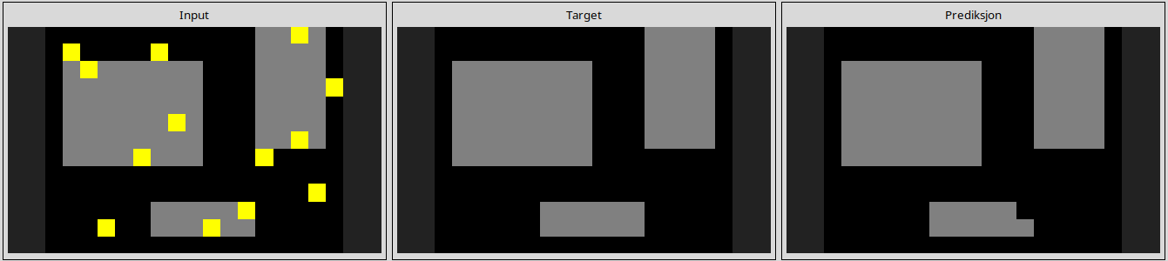
l
95990924
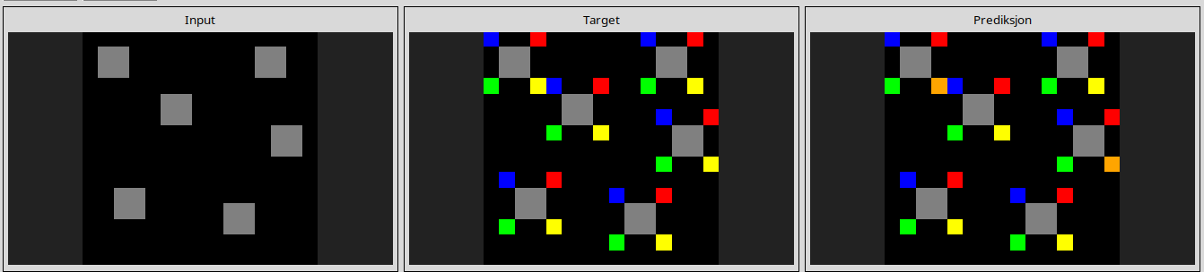
l
ba26e723
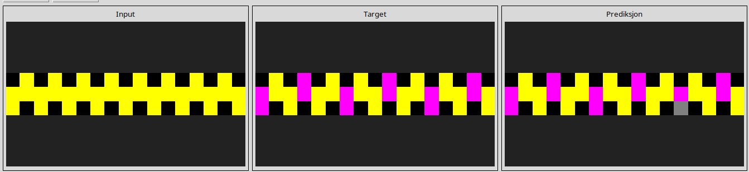
l
d13f3404
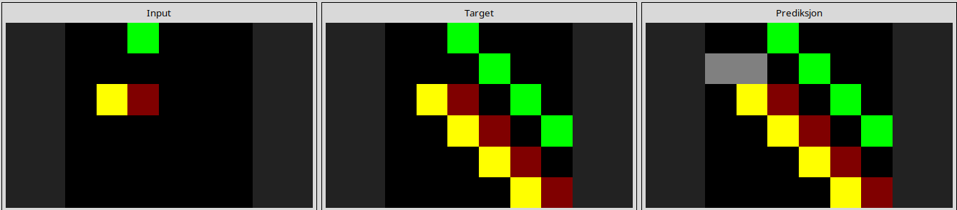
l
d4469b4b
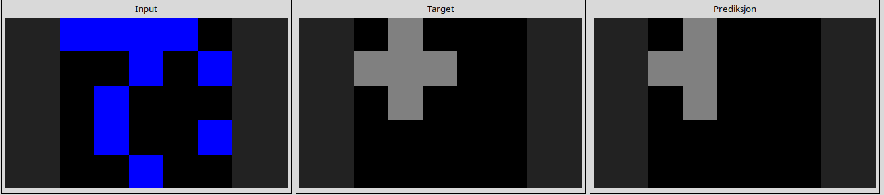
l
6d0aefbc
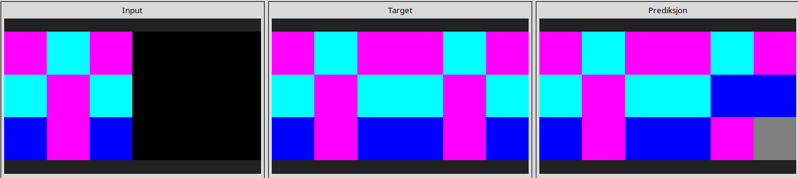
l
6fa7a44f
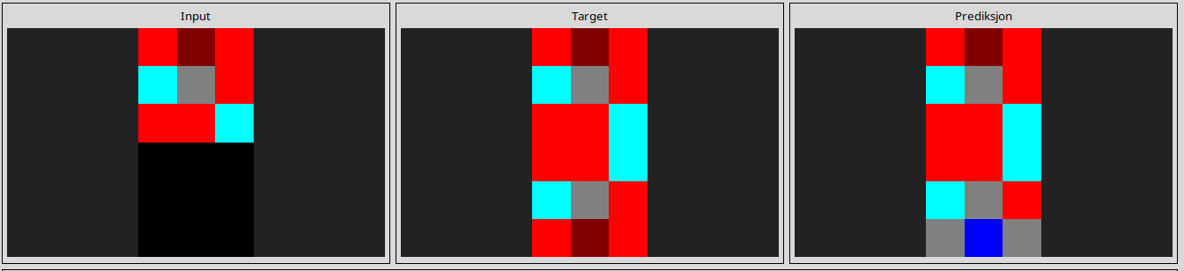
l
29c11459
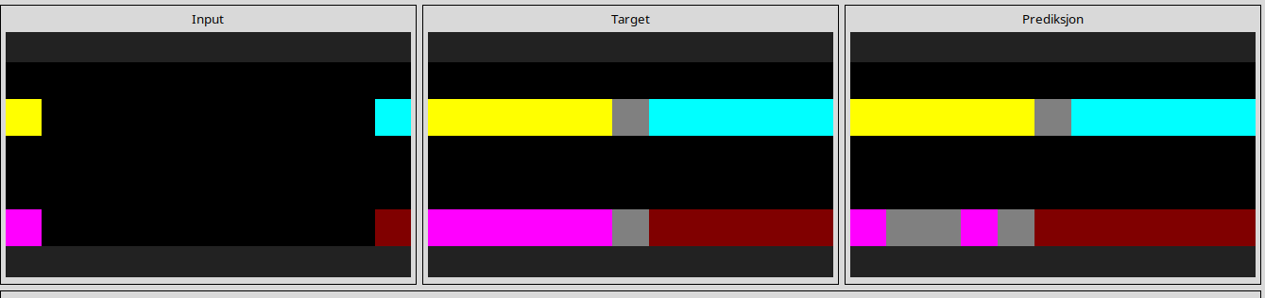
l
54d9e175
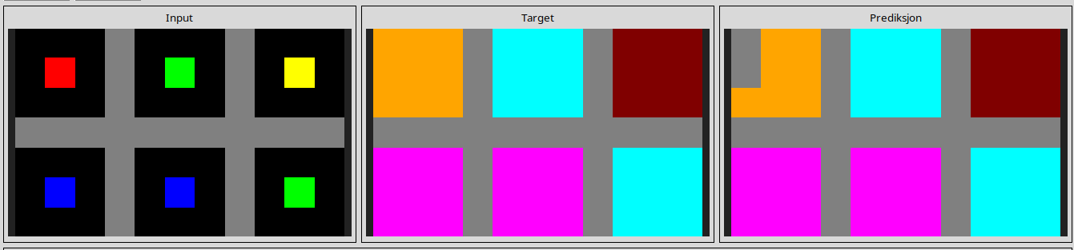
l
928ad970
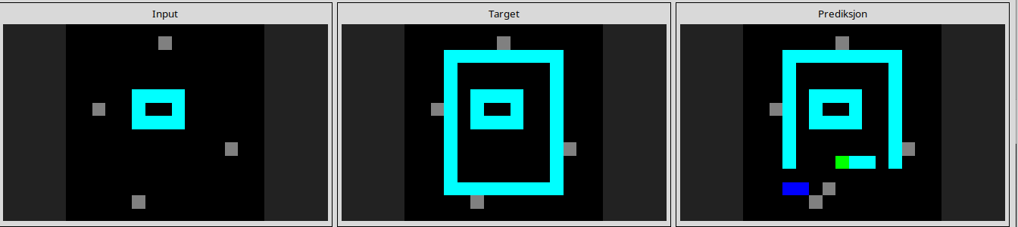
l
4612dd53
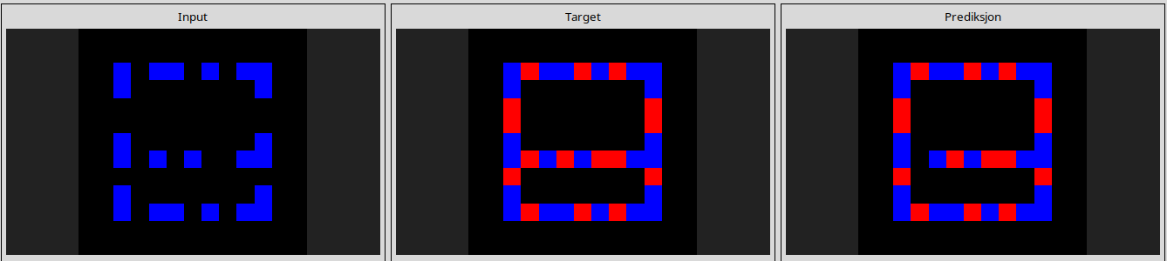
l
73251a56
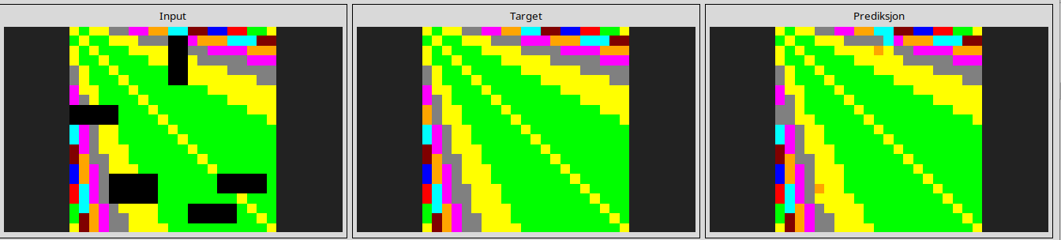
l
91714a58
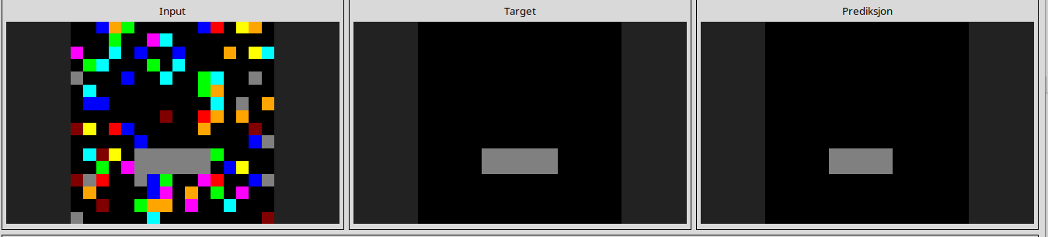
l
22168020
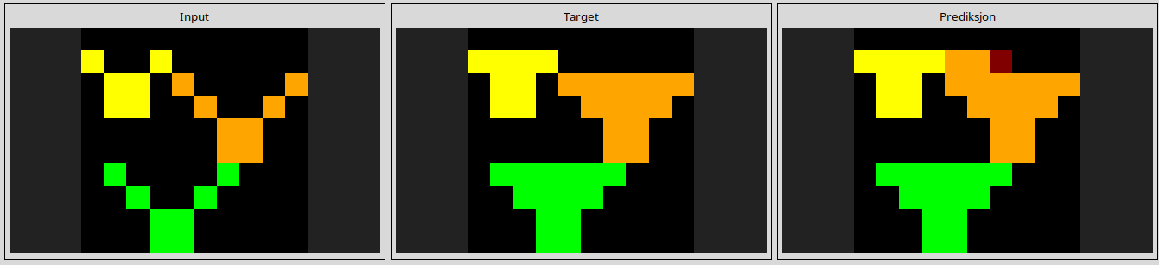
l
a78176bb
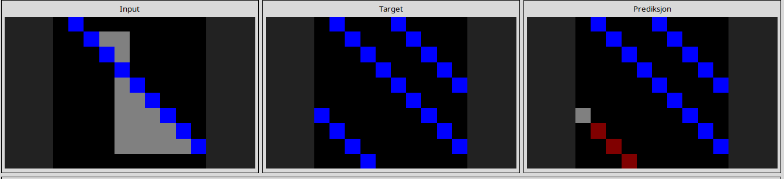
l
b8cdaf2b
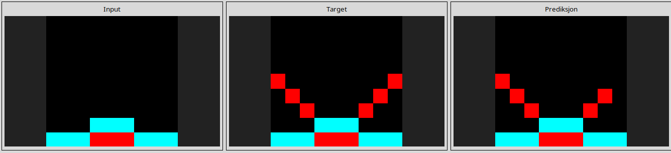
l
c3f564a4
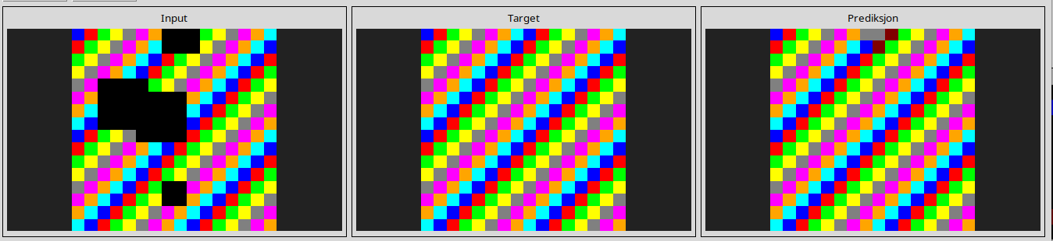
l
d9f24cd1
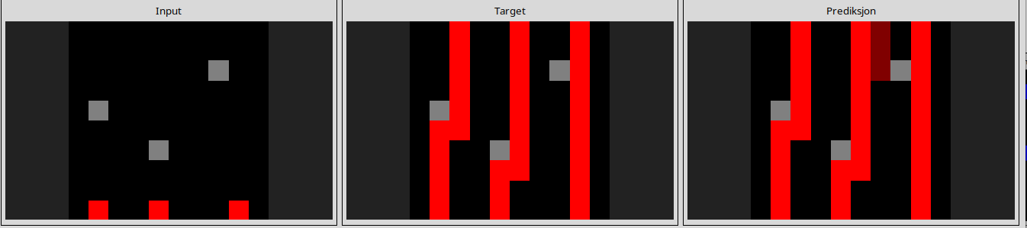
l
db3e9e38
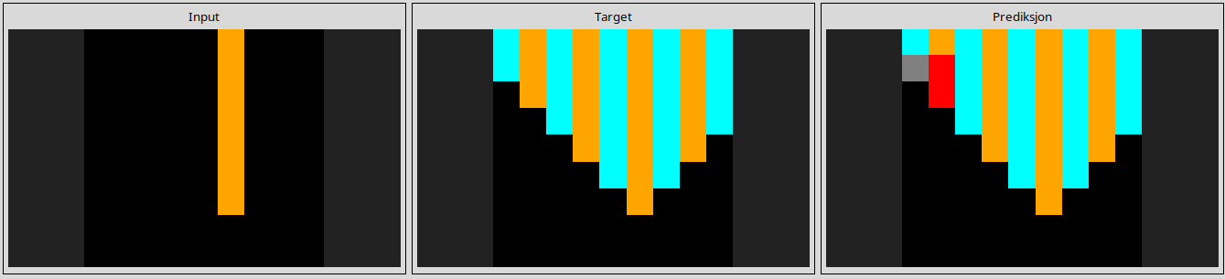
l
e73095fd
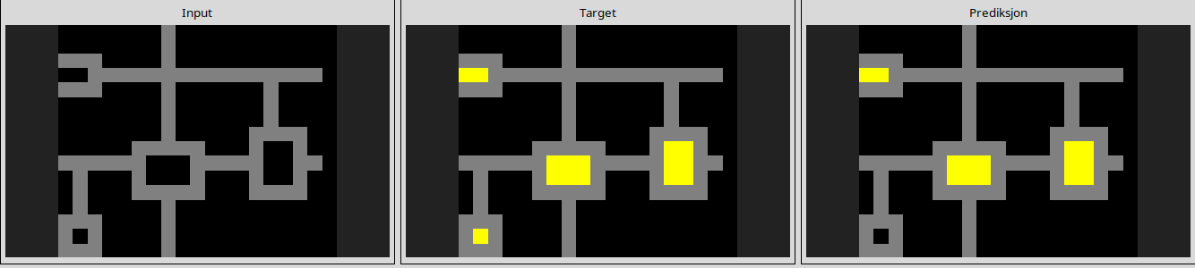
l
f8c80d96
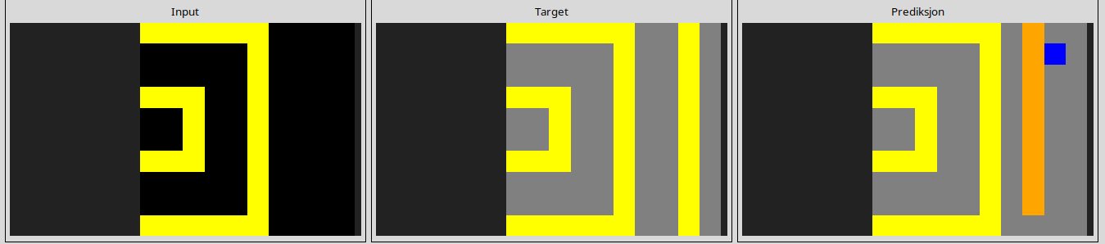
l
d6ad076f
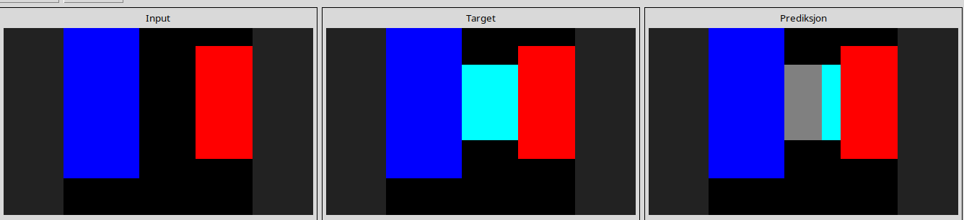
l
d07ae81c
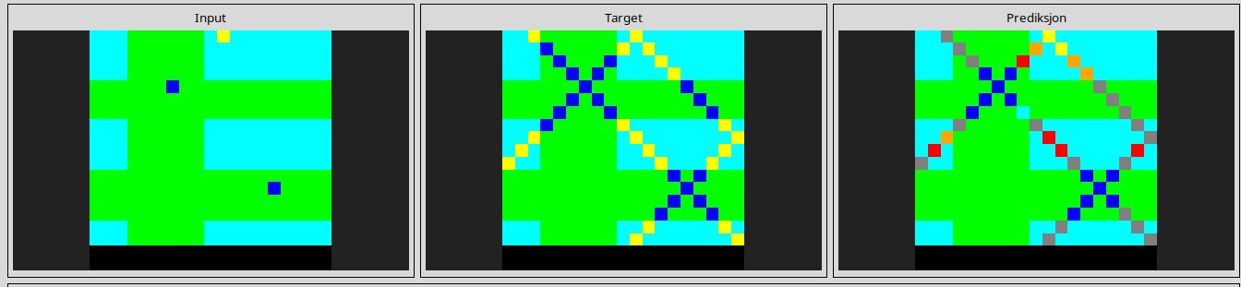
--------------------------------------------------------------------------------------------------------------------
Tasks that are ruined due to this to operation
0d3d703e

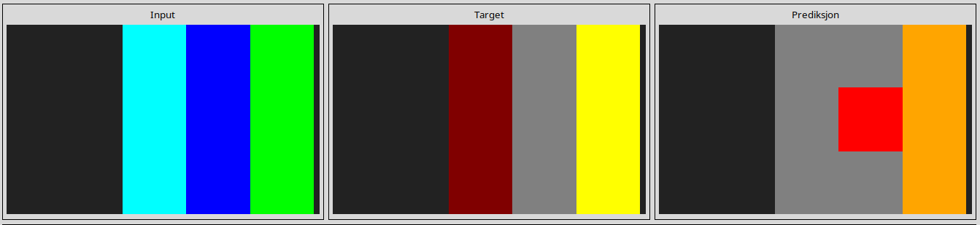
l
4258a5f9
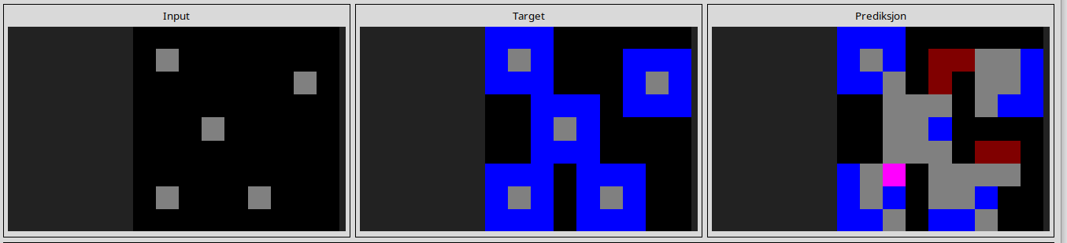
l
444801d8
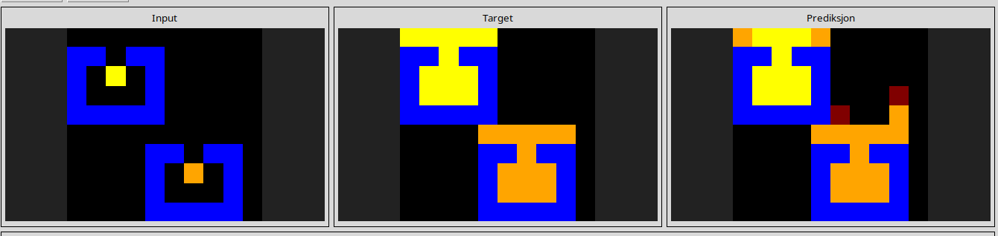
l
5168d44c
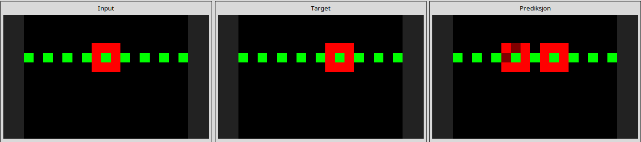
l
543a7ed5
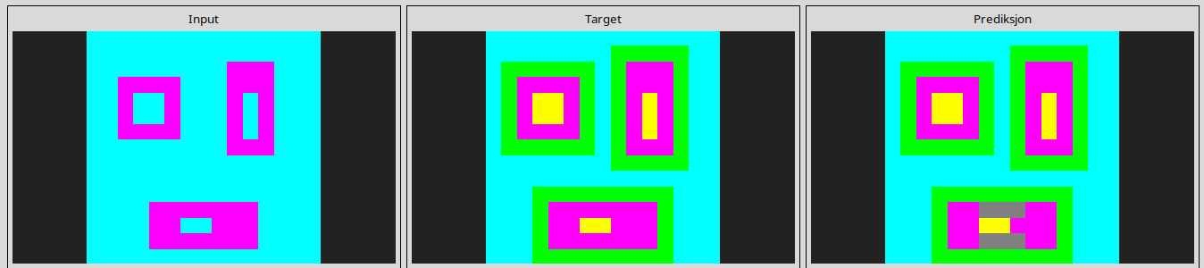
l
6f8cd79b
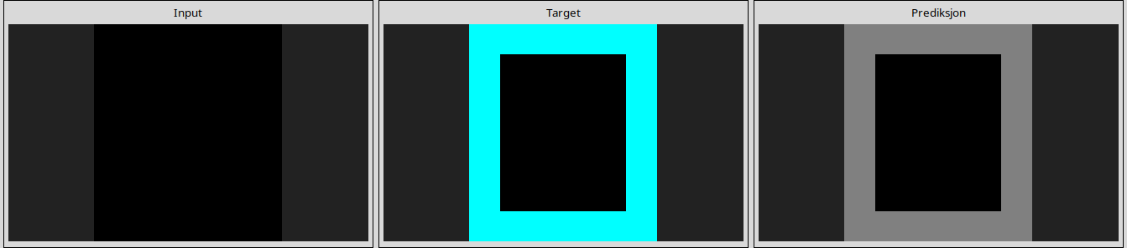
l
99fa7670
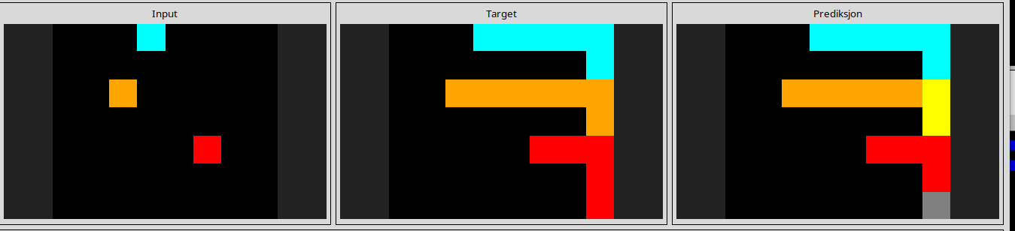
l
a699fb00
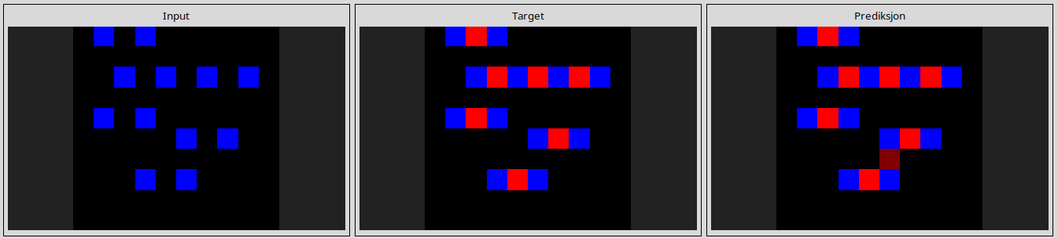
l
a79310a0
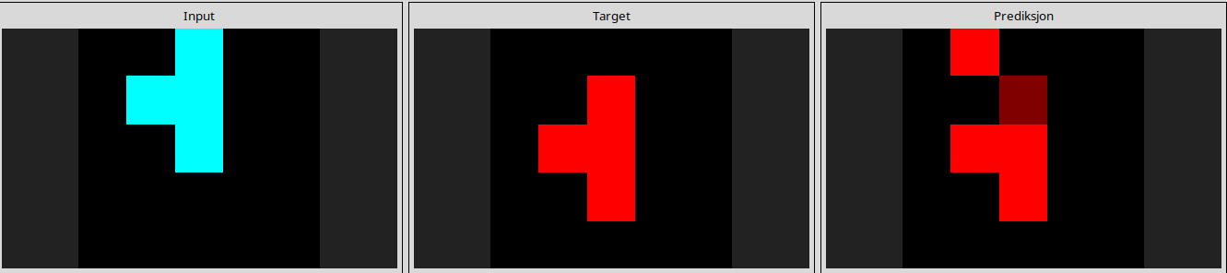
l
a85d4709
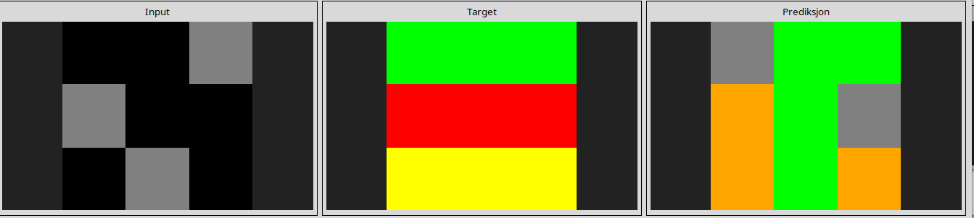
l
a9f96cdd
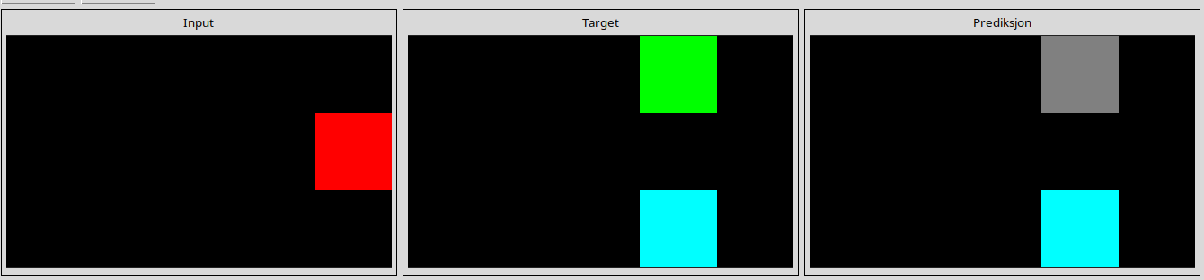
l
b60334d2
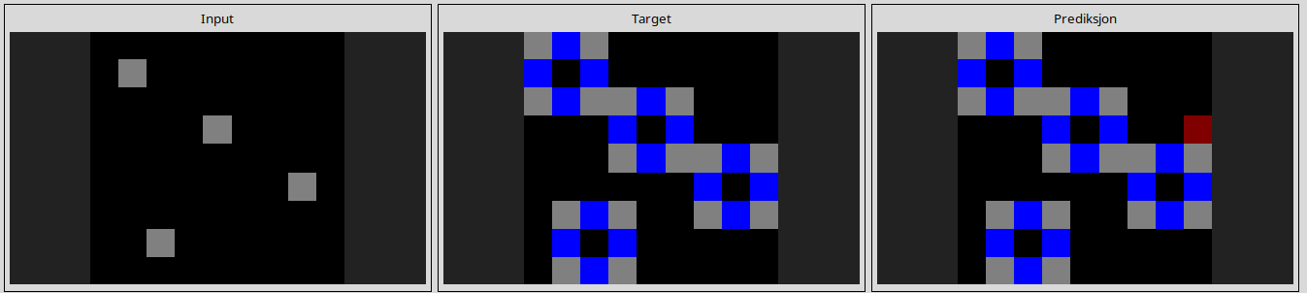
l
868de0fa
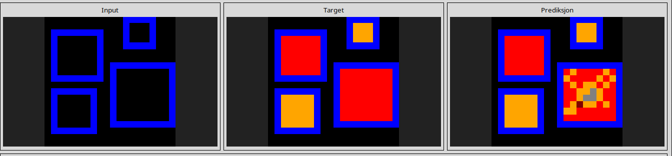
l
5c0a986e
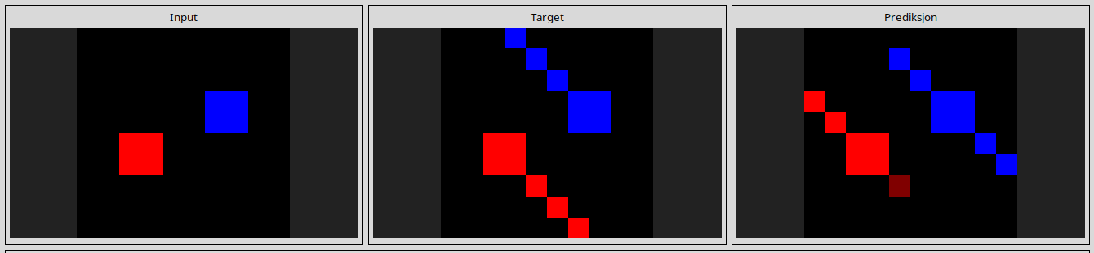
l
6cf79266
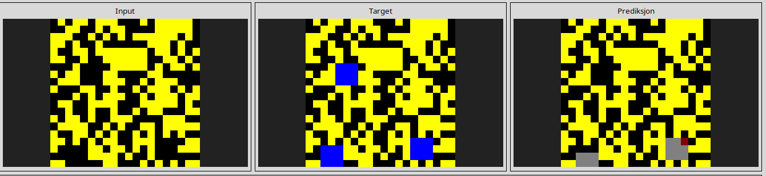
l
27a28665
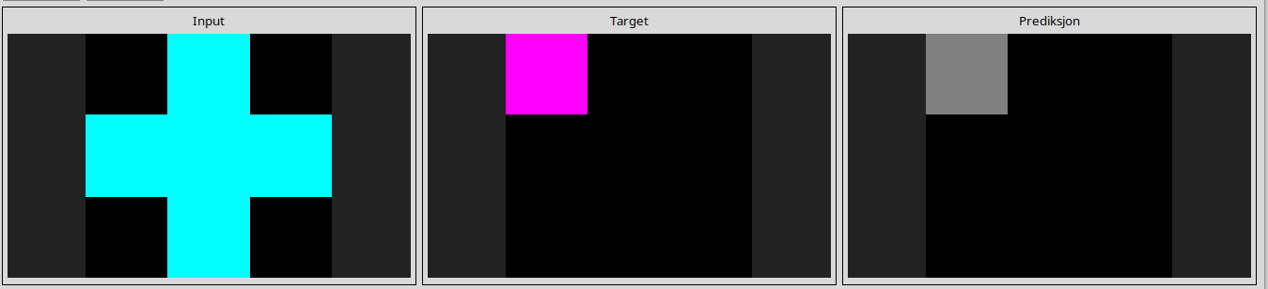
l
50cb2852
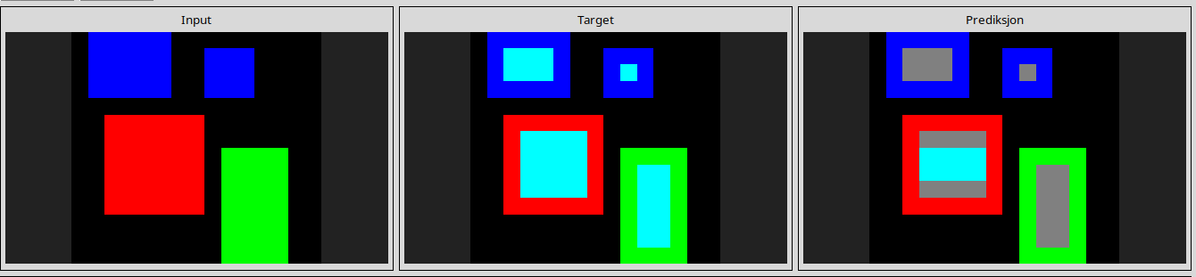
l
662c240a
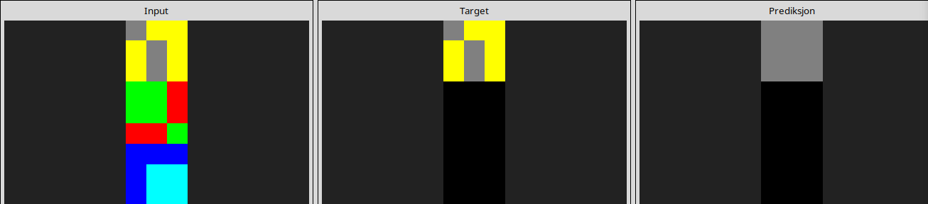
l
32597951
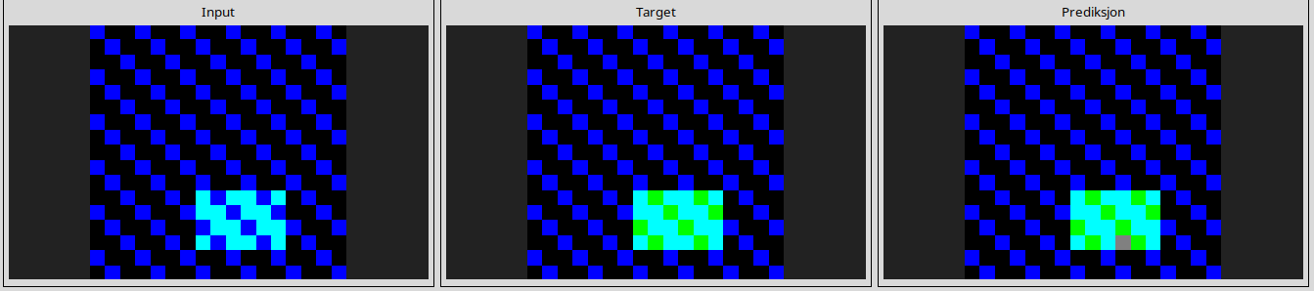
l
b1948b0a
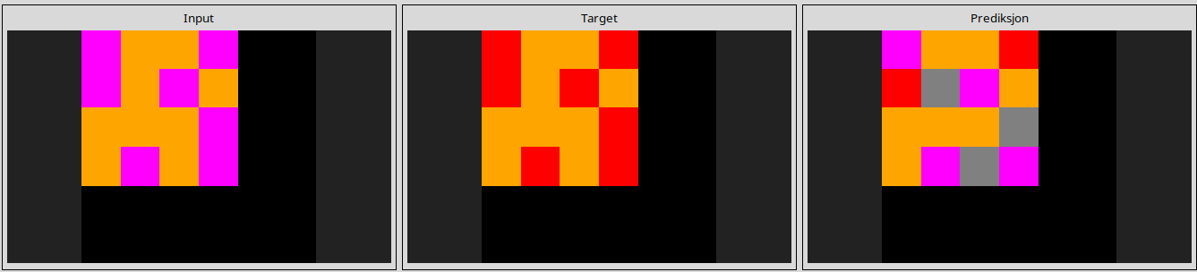
l
c8f0f002
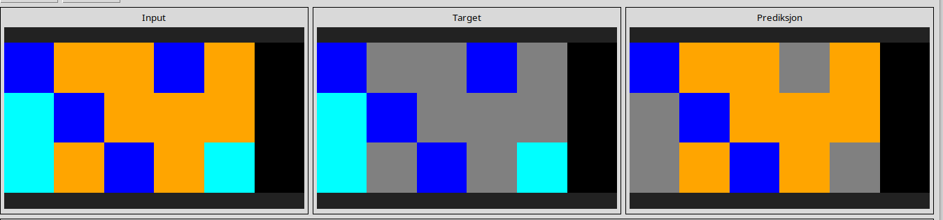
l
ce9e57f2
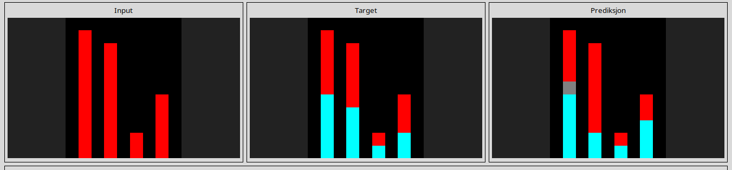
l
dc433765
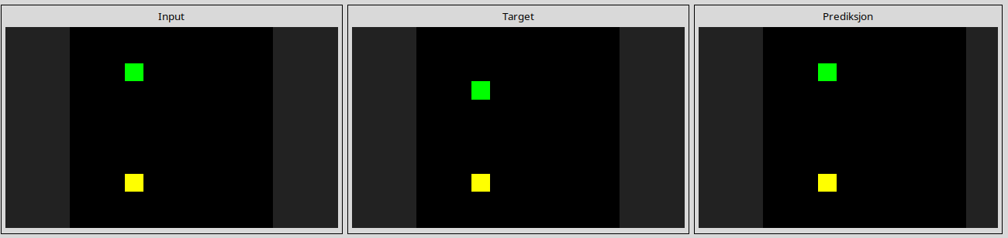
l
de1cd16c
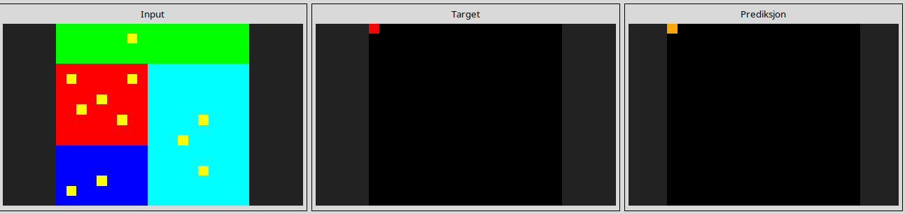
l
253bf280
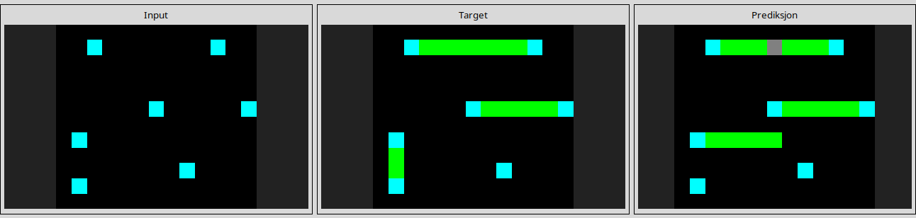
l
28e73c20
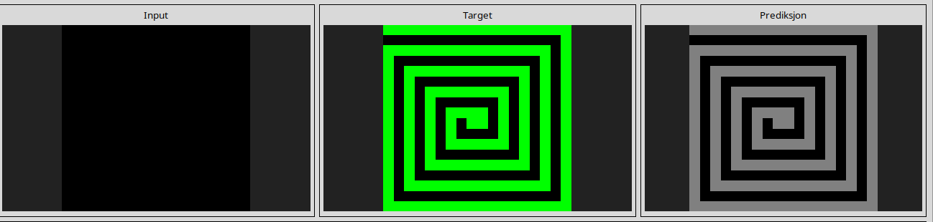
l
3bdb4ada
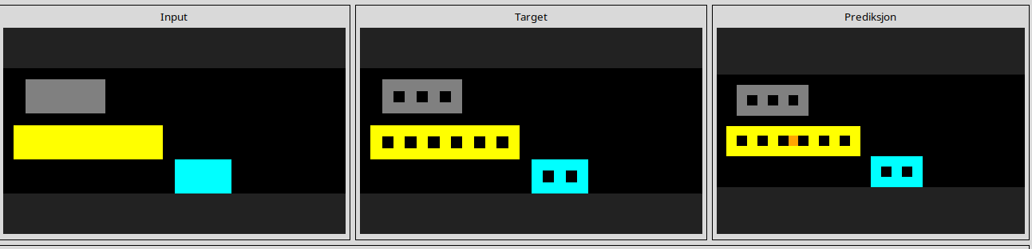
l
50846271
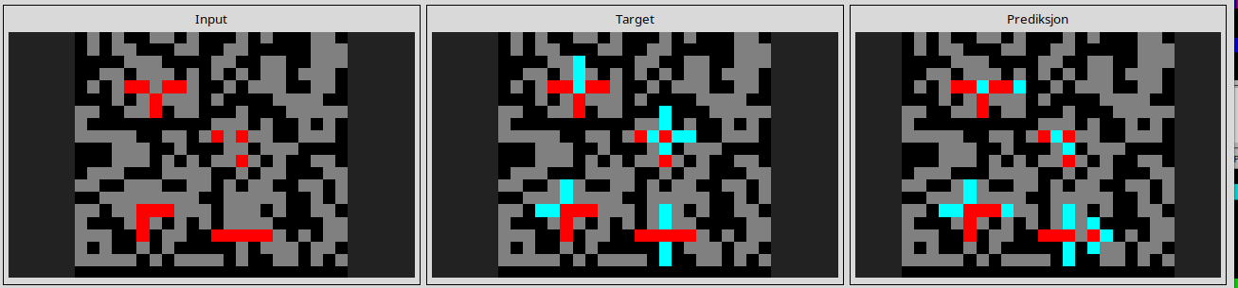
l
508bd3b6
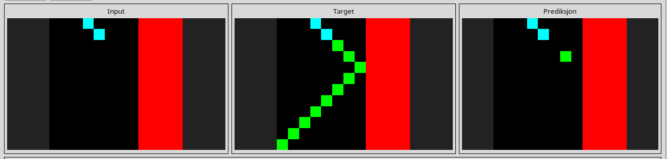
l
913fb3ed
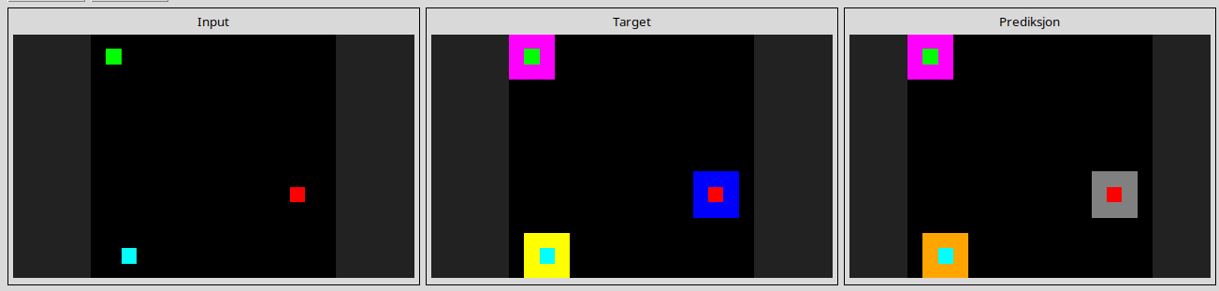
l
3bd67248
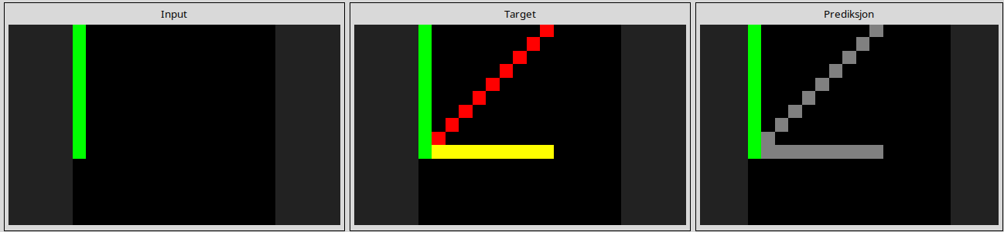
l
673ef223
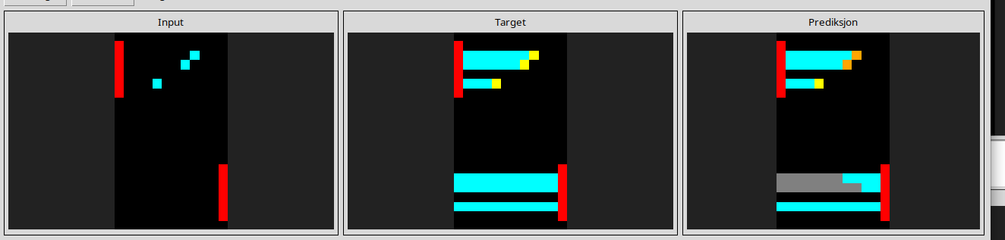
l
ec883f72
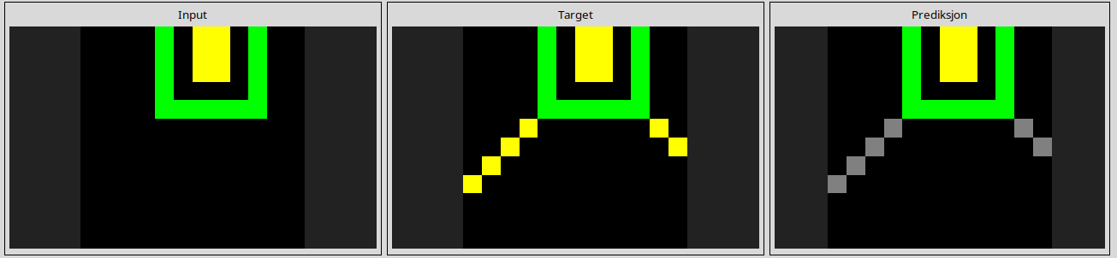
90f3ed37
